Tutorial – 05

Name : Ranudi Gayathmie Kariyapperuma
Index : 29897
Batch No : 23.1
Degree Program Name : Technology Management

Switch
Input two numbers and display the outputs of the basic mathematic operations. The output screen should be displayed as follows;

Enter two numbers ____ ____
1. +
2. –
3. *
4. /
Please enter your Choice ___

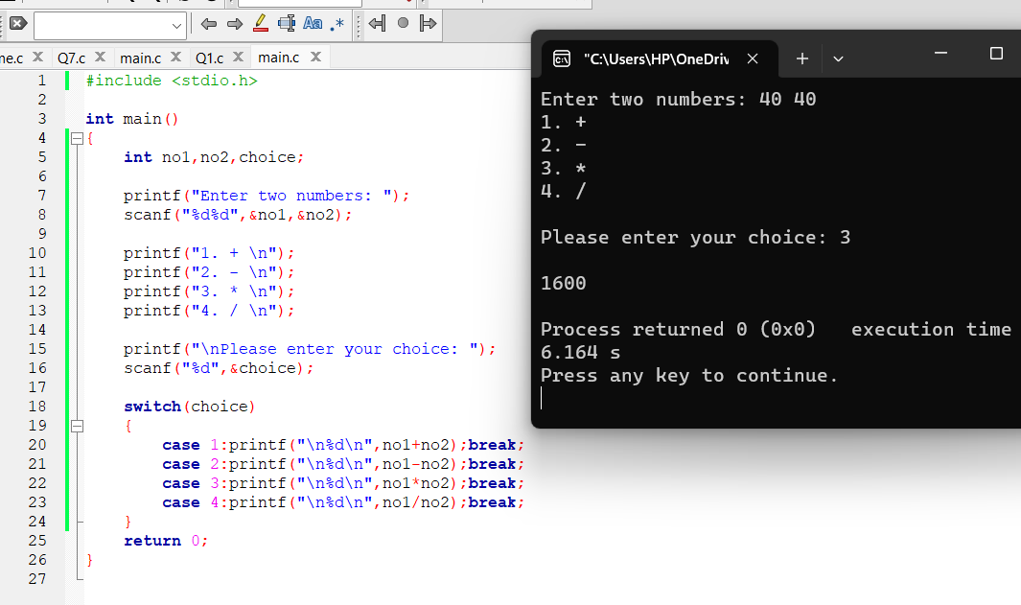
While loop
- Input 10 numbers and display the total count of odd & even numbers in the entered number series.
#include<stdio.h>
int main()
{
int no,counter=1,evenc=0,oddc=0;
while (counter<=10)
{
printf("Enter %d number: ",counter);
scanf("%d",&no);
if (no%2)
evenc++;
else
oddc++;
counter++;
}
printf("Total number of odd's %d \n",oddc);
printf("Total number of even's %d \n",evenc);
}
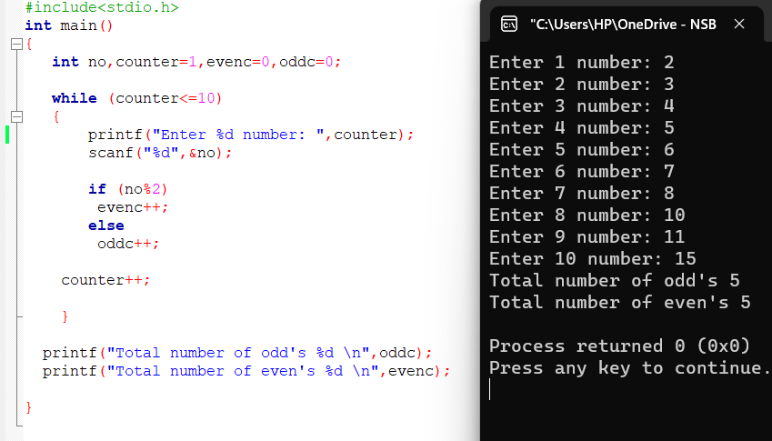
2.Modify the above program in to enter series of numbers terminates when the user enter -99 and display the same expected output.

#include<stdio.h>
int main()
{
int no,evenc=0,oddc=0;
printf("Enter numbers (-99 to terminate)\n");
while (1)
{
printf("Number: ");
scanf("%d", &no);
if (no == -99)
{
break;
}
if (no%2)
evenc++;
else
oddc++;
}
printf("Total number of odd's %d \n",oddc);
printf("Total number of even's %d \n",evenc);

}

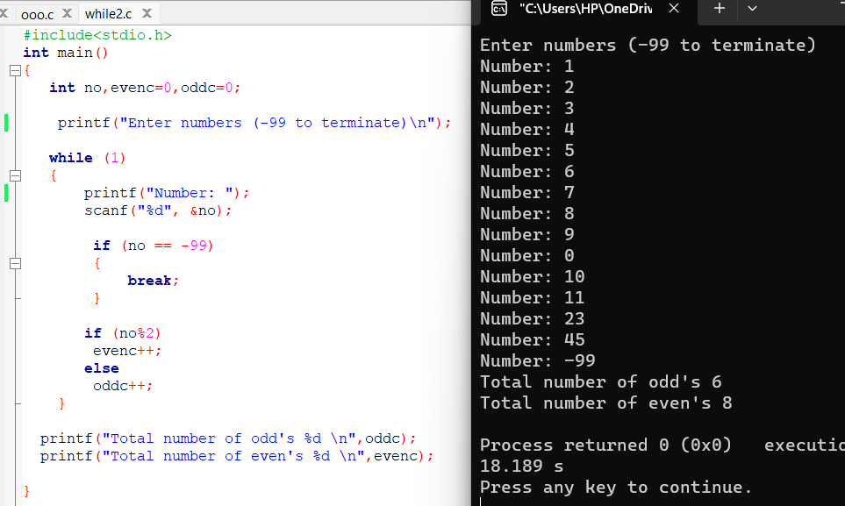

Do while loop
Rewrite the programs for the above while loop question 1 & 2 using do while loop

1 #include<stdio.h>
int main()
{
int no,counter=1,oddc=0,evenc=0;
do
{
printf("Enter %d number : ",counter);
scanf("%d",&no);

if(no%2==0)
evenc=evenc+1; //evenc++;
else
oddc=oddc+1;//oddc++;

counter++;

}while(counter<=10);

printf("Total number of even's %d\n\n",evenc);
printf("Total number of odd's %d\n",oddc);

return 0;
}

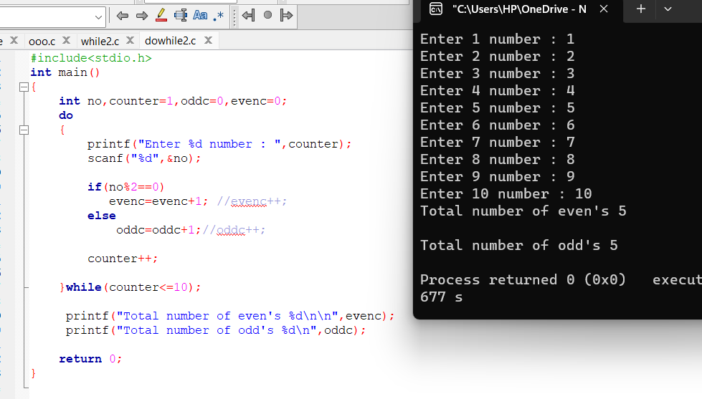

#include<stdio.h>
int main()
{
int no,oddc=0,evenc=0;

printf("Enter numbers (-99 to terminate)\n");

do
{
printf("Number:");
scanf("%d",&no);

if (no == -99)
{
break;
}

if(no%2==0)
evenc=evenc+1; //evenc++;
else
oddc=oddc+1;//oddc++;

}while(1);

printf("Total number of even's %d\n\n",evenc);
printf("Total number of odd's %d\n",oddc);

return 0;
}

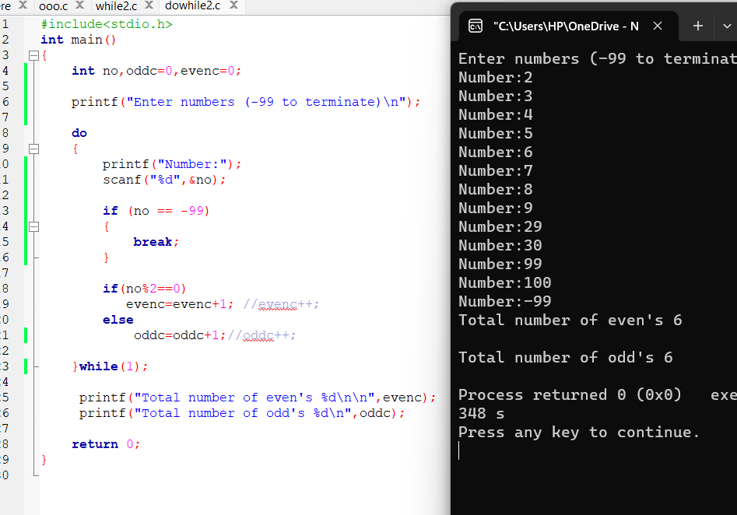

For loop
- Input 10 numbers and display the average value using the for loop

#include <stdio.h>
int main()
{
int no,counter,total=0;
float avg;
for (counter = 1; counter <= 10; counter++)
{
printf("Enter %d number :",counter);
scanf("%d",&no);
total+=no;
}
avg=(float)total/10.0;
printf("The average is %2f \n",avg);
return 0;
}
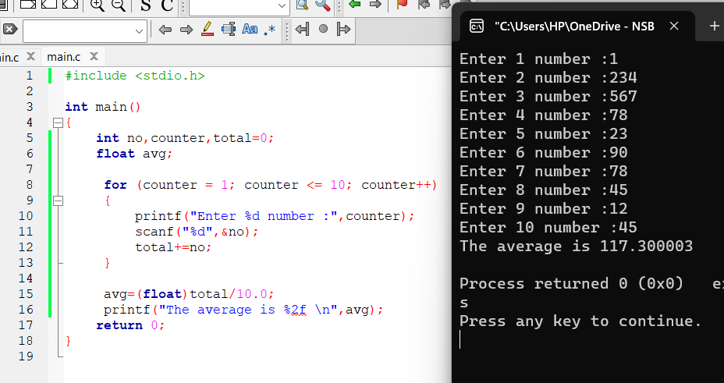
2. Display the following output using the for loop
*
**
***
****
*****

#include <stdio.h>
int main()
{
int a,r;
for(a=1;a<=5;a++)
{
for(r=1;r<=a;r++)
{
printf("*");
}
printf("\n");
}
return 0;
}

